ArcGIS Pro – Session Three

Connecting to Local Data

The following step-by-step guide will help you to cconnect to Local Data such as might be stored in a Microsoft Excel spreadsheet or comma separated variable (.csv) file. This can be useful when data is in tabular form and you wish to plot latitude and longitude on a map for analysis or even create a graphic that can then be shared through the web. Addresses can also be plotted directly and ‘Geocoded’ using tools built into the GIS.

In recent releases of ArcGIS Pro, Microsoft Access databases can be utilized as well. ArcMap, another GIS created by ESRI, can create “Personal Geodatabases” for storing information and shapes. These personal geodatabases are simply Microsoft Access databases (.mdb), but they contain a few extra tables that allow for the software to process them properly. ArcGIS Pro was unable to connect to these until recently. Now the software can connect to Microsoft Access databases as “Personal Geodatabases” even if they do not contain the extra tables that make up a “Personal Geodatabase”.

In this session we will plot points directly from a ready-made .csv file that contains latitude and longitude. We will then process these points by converting them into polygons. Following that, we will explore some geometry editing tools including split and merge while expanding on our knowledge of styling the layer according to an attribute.

We will briefly explore graph creation before performing an analysis and then publishing our results to our ArcGIS Online account. This gives us the opportunity to understand how ArcGIS Pro can help us all be more ‘connected’ and automatic with our data collection, manipuulation, and sharing of knowledge.

During the session we will also touch on the use of Google Earth and how to import data from that software into the GIS using tools available.

Ultimately, we will publish layers to an ArcGIS Online account and import those layers back into ArcGIS Pro.

- Start a new ArcGIS Pro Project and save it in your Working Folder on the C Drive. Name it “Session Three – Connect to local data”. Remember, you can ‘Start Without a Template”.
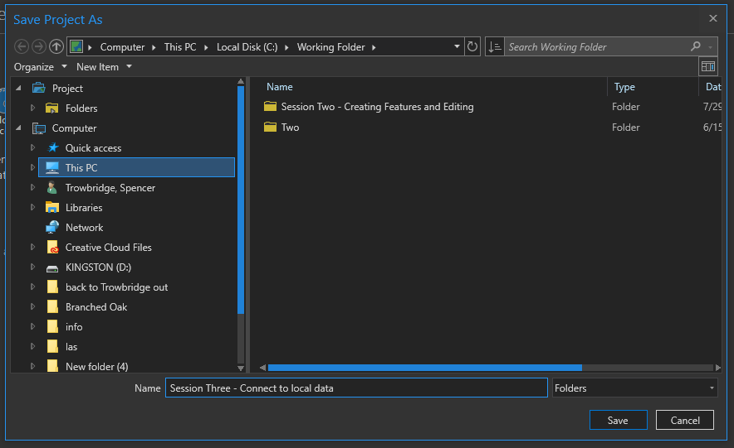

- Just for practice - Add a Folder Connection to the Working Folder on the C Drive. You will already have a connection to the subfolder “Session Three – Connect to local data”. (Right-click on Folders in the Catalog pane followed by selecting “Add Folder Connection”)
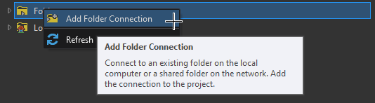
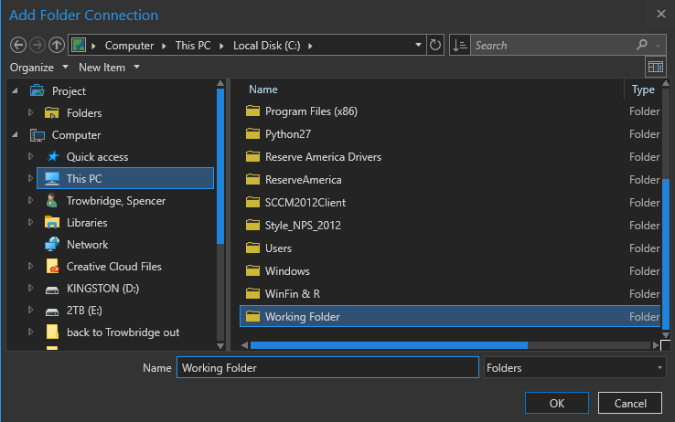
The folder connections should look like this when finished.
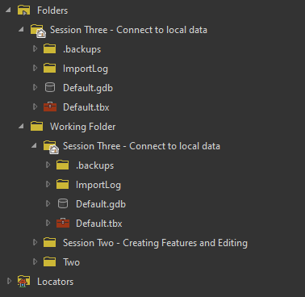
- Inside the “Session Three – Connect to local data” folder on the C Drive (inside the Working Folder), create another New Folder. Name it “Session Three - DATA”.
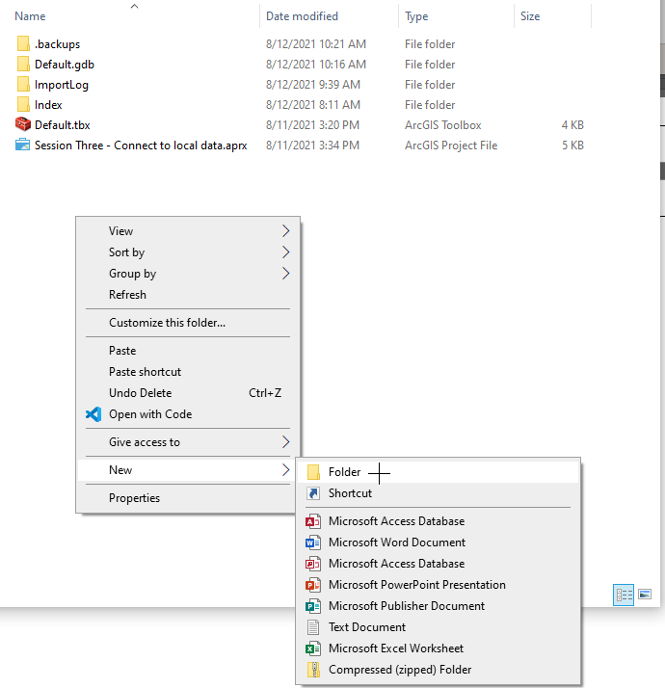
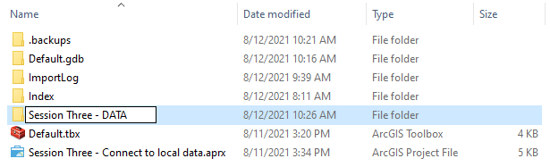
- Navigate to the W Drive to obtain ready-made data. Copy all of the files from this location into the Session Three – DATA” folder.

W:\All Users\GIS\ArcGIS Pro Sessions\Session Three DATA

Pasted here – Note the path of the files.
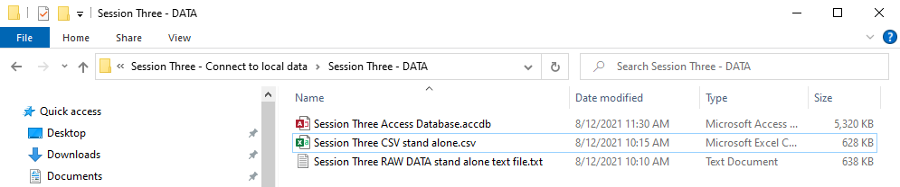

- In ArcGIS Pro, right-click the folder connection “Session Three – Connect to local data”, then select “Refresh”. The new folder “Session Three – DATA” should appear.
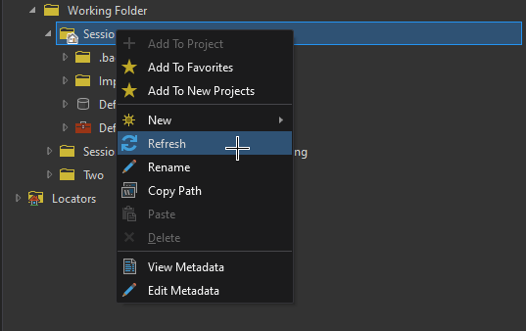
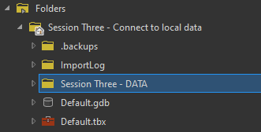
- Expand the DATA folder to see the files within it. Notice that the .accdb file does not appear. The .accdb is a database and is ‘found’ by ArcGIS Pro using the Databases option.
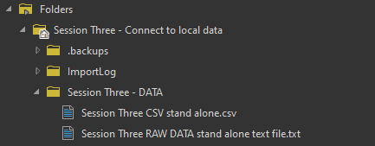

- To connect to the .accdb, navigate to the Databases at the top of the Catalog pane. Right-click on “Databases” and choose “New OLE DB Connection”.
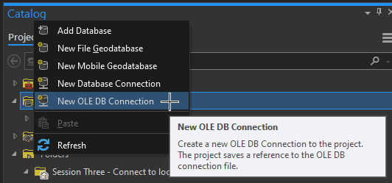

- Choose, “Microsoft OLE DB Provider for ODBC Drivers”, followed by “Next”.
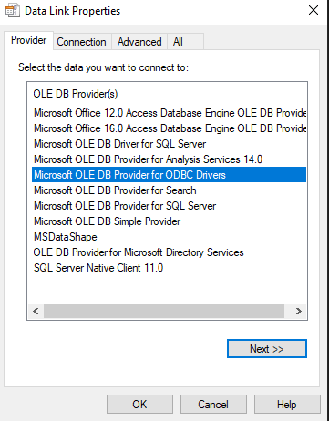

- Copy the path of the Session Three – DATA folder to the clipboard (Copy address as text).
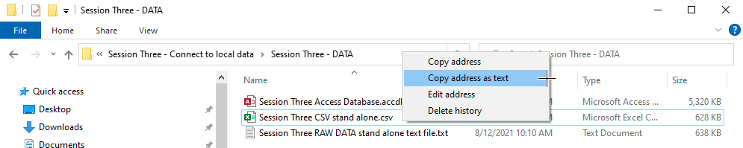
- Back in ArcGIS Pro, choose “MS Access Database” from the drop-down under “Use data source name” in the Data Link Properties dialogue window.
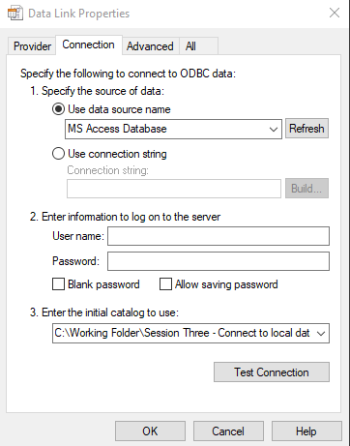

- Paste the path of the DATA folder into the Number 3 field, “Enter the initial catalog to use:”.

NOTE: you will have to ammend the ending of this field’s text with the actual name of the Access database file, including the .accdb extension, or .mdb if needed.
(The full path will be: C:\Working Folder\Session Three - Connect to local data\Session Three - DATA\Session Three Access Database.accdb)
Test the connection. If successful, click OK to close, then OK again on the main Data Link Properties dialogue window to make the actual connection.
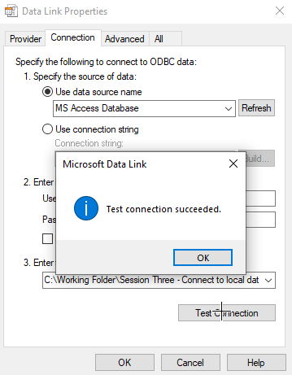
- The new OLE DB Connection is then made. After expanding the connection, it shows two Tables that were previously imported for this Session. Please take note of the names for these files compared to the stand alone tables found in the DATA folder. All of the tables should be identical. They were simply converted to .csv then named differently to help demonstrate the different connectivity options available in ArcGIS Pro.
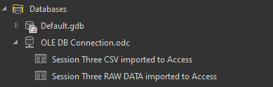

- Right-click on the Session Three RAW Data stand alone text file and choose Add to new Map.
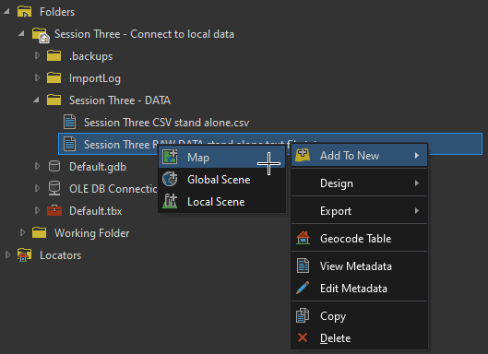
- The table is added to the Table of Contents, but at the bottom.
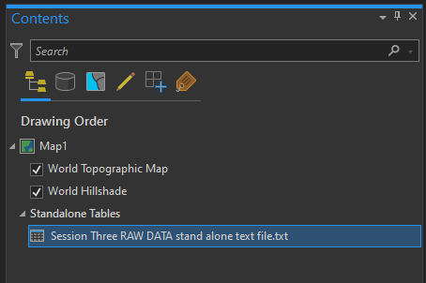

- Nothing is displayed ‘on the map’ yet. To do so, right-click on the table and choose, “Display X and Y data”.

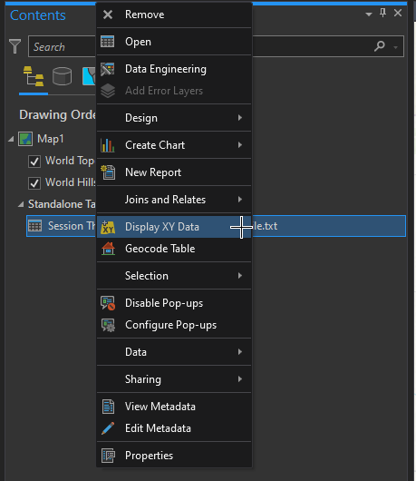

- ArcGIS Pro knows to check for several field names that are somewhat standard such as latitude and longitude. The Display XY Data dialogue window is automatically populated here, but other data for X Field and Y Field may have to be manually chosen.
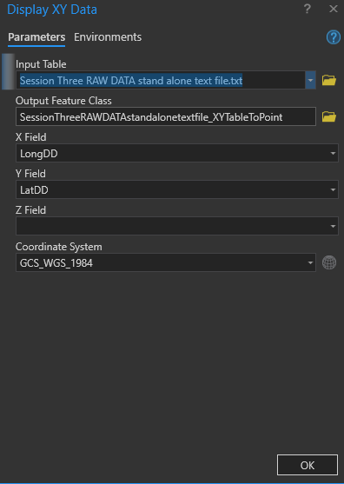

- Click OK to plot the points on the map.
This is well data for Thayer County, NE from the Department of Natural Resources. There appears to be one outlier in this dataset.
https://nednr.nebraska.gov/Dynamic/Wells/Wells/WellsBarDelimitedView?Filters.AddressSearchField=&Filters.CitySearchField=&Filters.OwnerIdSearchField=&Filters.CompletionBeginDate=&Filters.CompletionEndDate=&Filters.DecommissionBeginDate=&Filters.DecommissionEndDate=&Filters.FirstNameSearchField=&Filters.LastNameSearchField=&Filters.NrdPermitNumberSearchField=&Filters.NrdPermitPrefixId=&Filters.OnlineRegistrationIdSearchField=&Filters.RangeDirectionSearchField=&Filters.RangeSearchField=&Filters.RegistrationBeginDate=&Filters.RegistrationEndDate=&Filters.RegistrationNumberSearchField=&Filters.SectionSearchField=&Filters.TownshipSearchField=&Filters.WellIdSearchField=&Filters.ZipCodeSearchField=&Filters.CountyIds%5B0%5D=85&barType=0
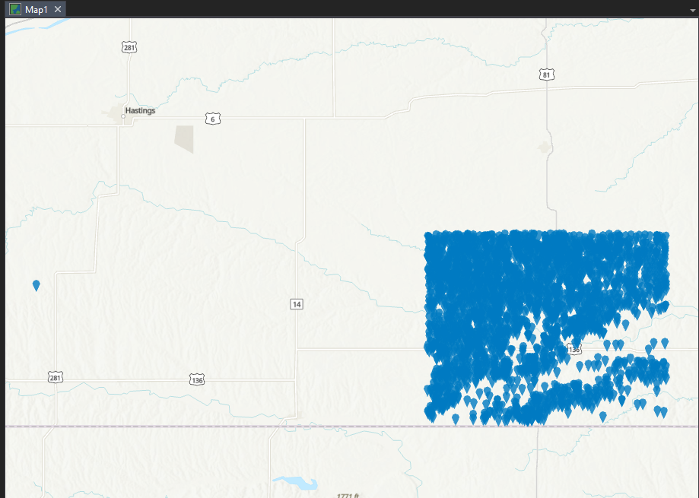

- Experiment with the attribute table and styling the map according to the data.
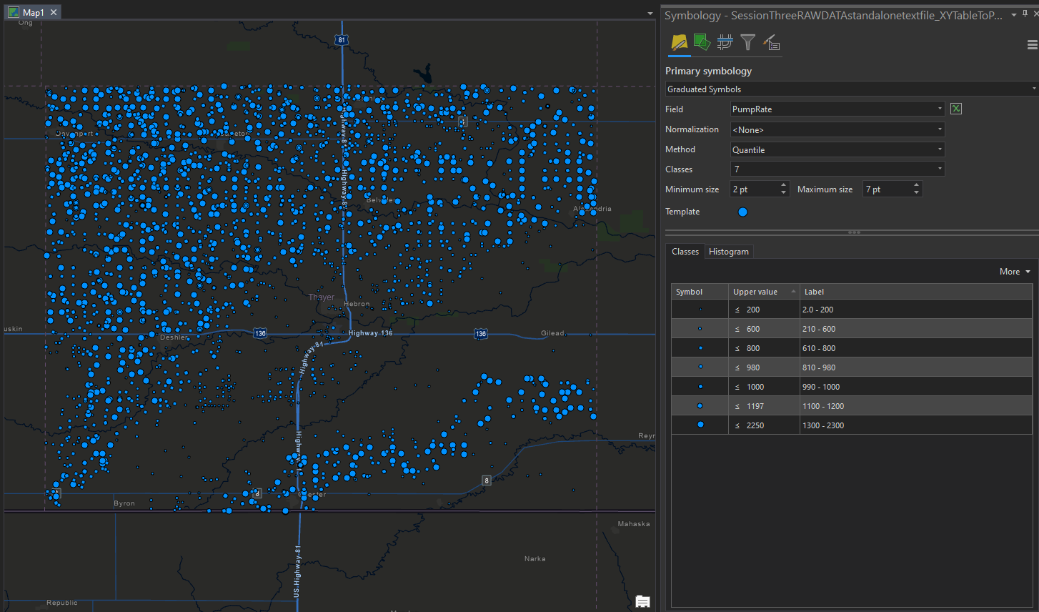

- Here the data in the stand alone Text file has been edited from within ArcGIS Pro. While only this one well’s data has been changed, it could have just as easily been joined to new data and all of the data mass-replaced.
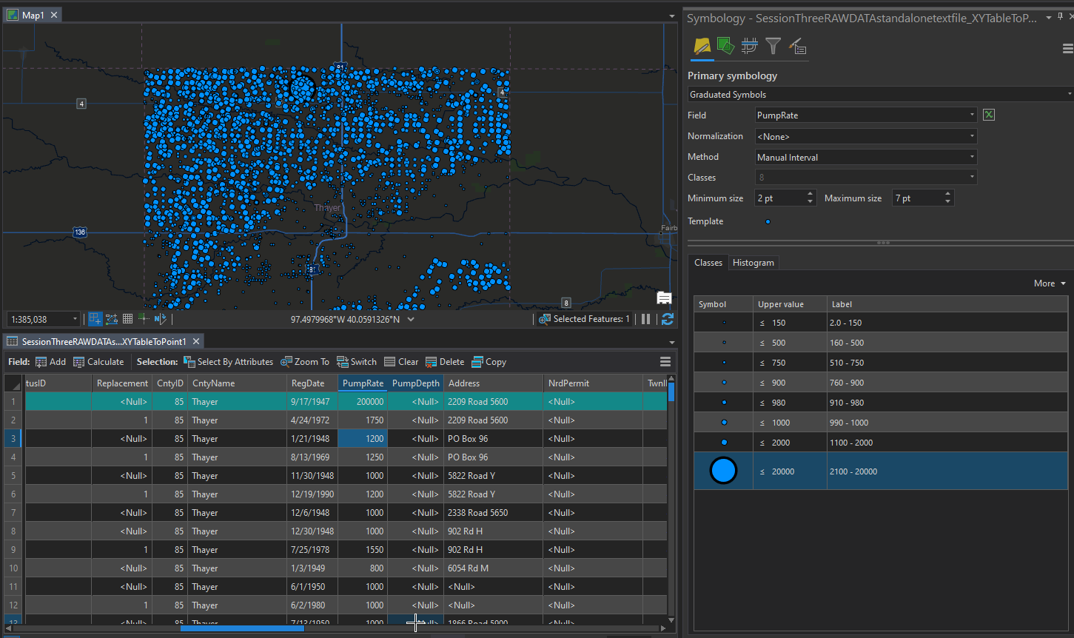

- Import data from the Access database tables. Choose the table created from the CSV file. (Add to Current Map)
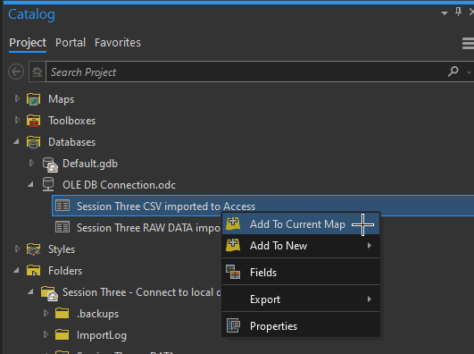

- Again choose “Display XY Data” after right-clicking the layer. NOTE: The name has apostrophes and the Display XY Data tool will not function. The Red “X” is observed when a tool will not run.
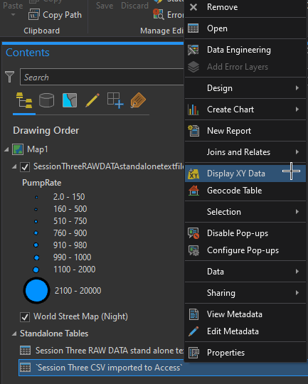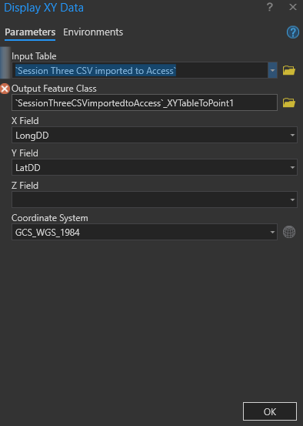

- Remove the apostrophes in the Table of Contents then Display the XY Data.
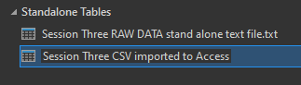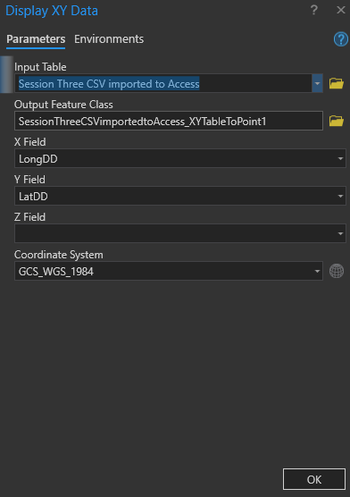

- Practice displaying the four tables as XY Data. Remember to remove the apostrophes from the tables within the Access DB in the Table of Contents.
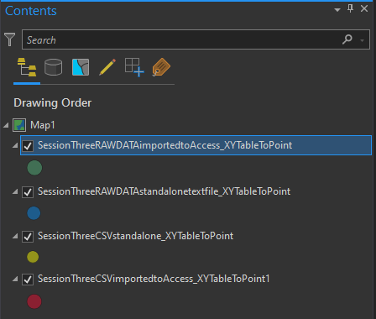

- Right-click any of the XY Layers and hover over “Data”, then choose “Export Features”.

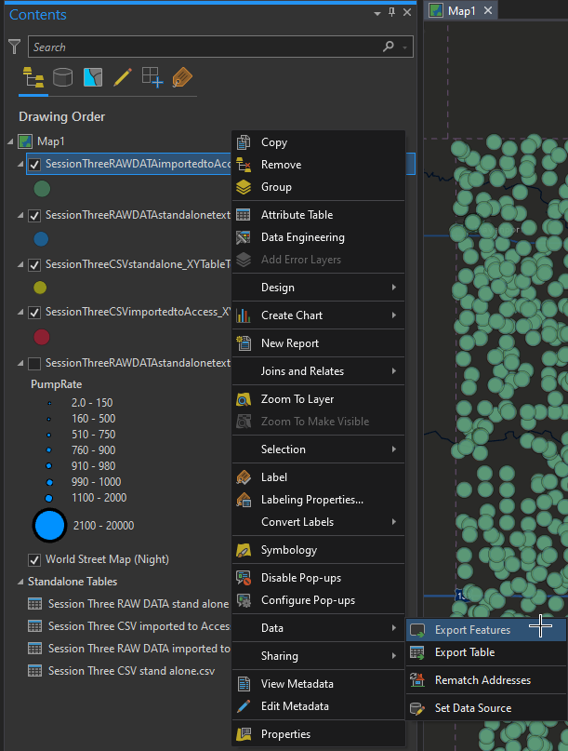

- Fill in the appropriate fields to export this layer to the Session Three – DATA folder with the name “EXPORTED_FROM_PRO”. NOTE: the file extension will be set to .shp (shapefile).
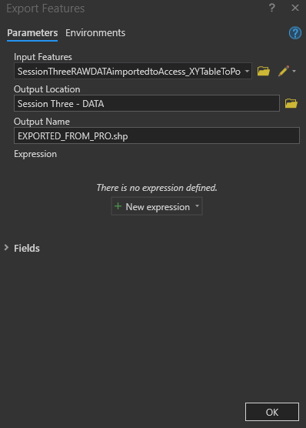
- The new shapefile is automatically added to the Table of Contents.

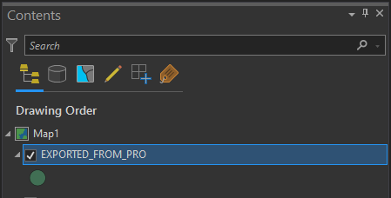

- The Session Three – DATA folder now looks like this:

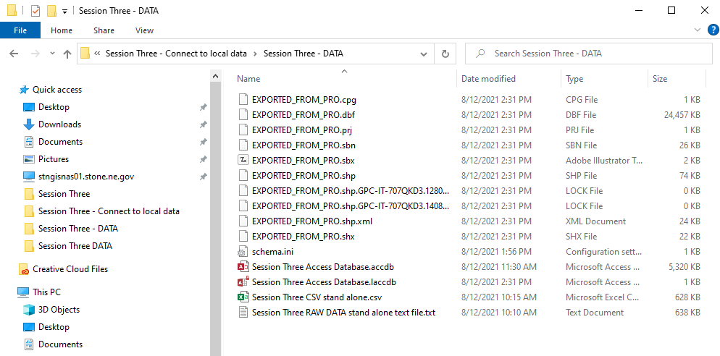

- Minimize ArcGIS Pro, then open Google Earth, if you have it installed.

- Click File then Open and choose “ESRI Shape (*.shp)”.
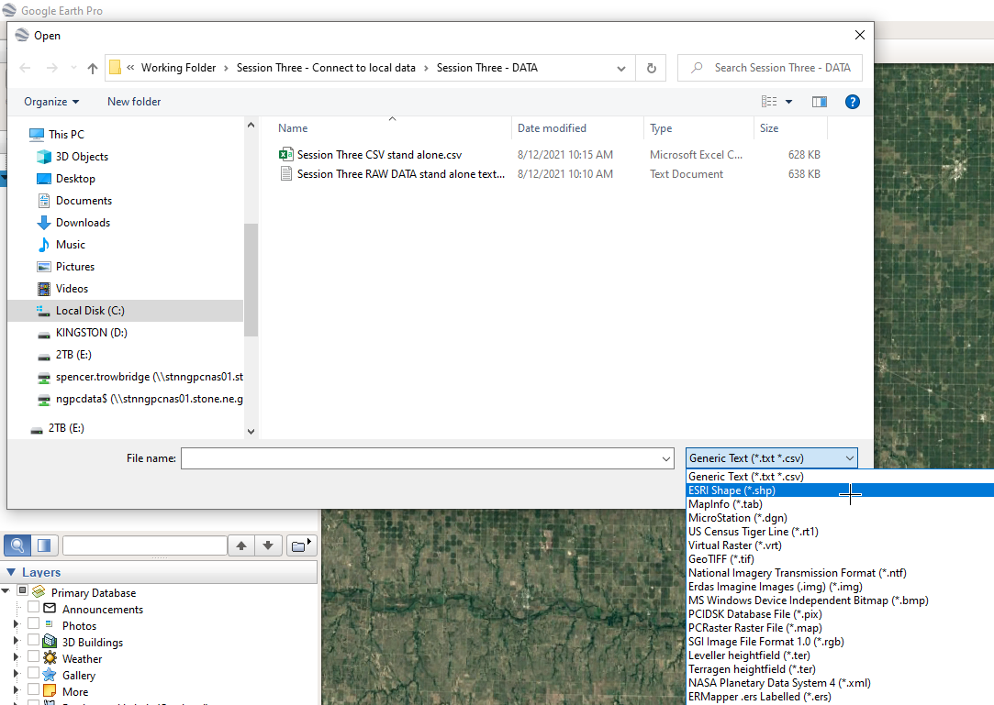

- Select the “EXPORTED_FROM_PRO.shp” followed by Open to add it to Google Earth.
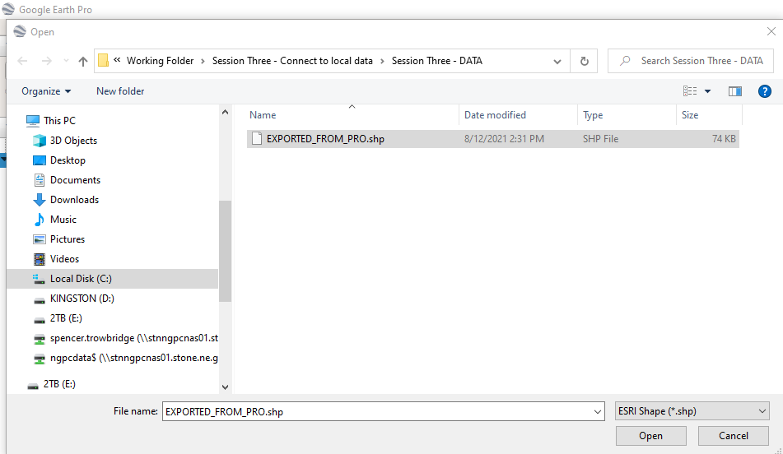
Import All Features and don’t bother with a style template.
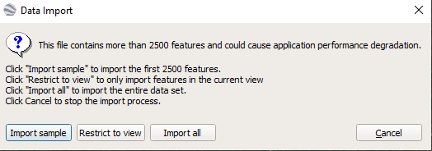
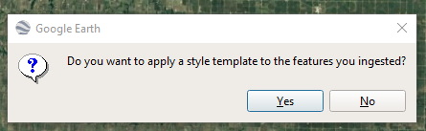

- Click the layer On to see the points in Google Earth.
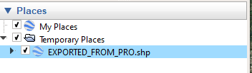
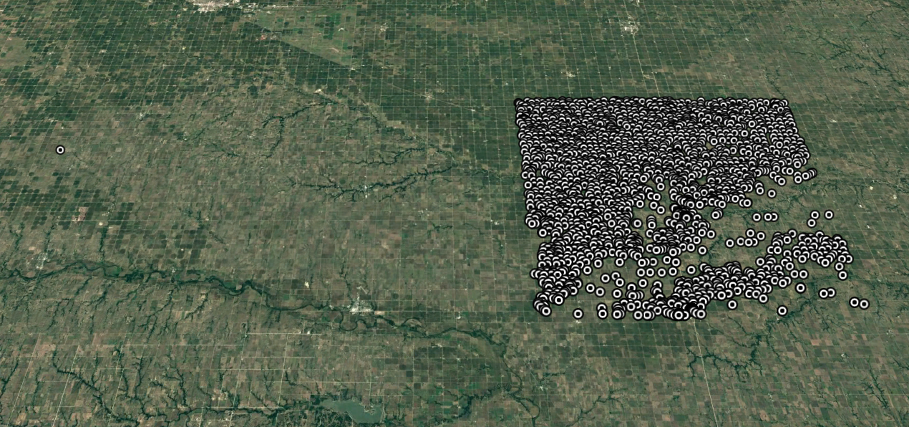
- Right-click the layer and select “Copy”.

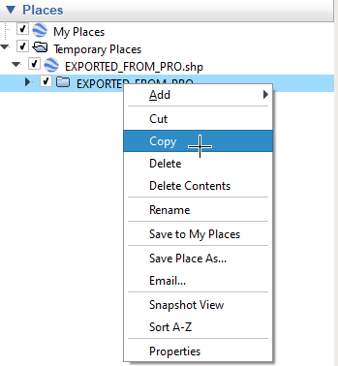

- Open a Text Editor such as Notepad.

- Paste the contents of the clipboard into the text document.

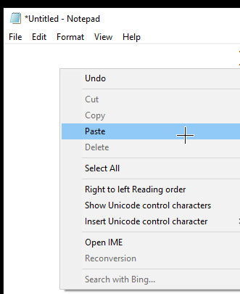

- Select File then choose Save as… and name the file “FROM_GOOGLE_EARTH.kml”. Save it in the Session Three – DATA folder.

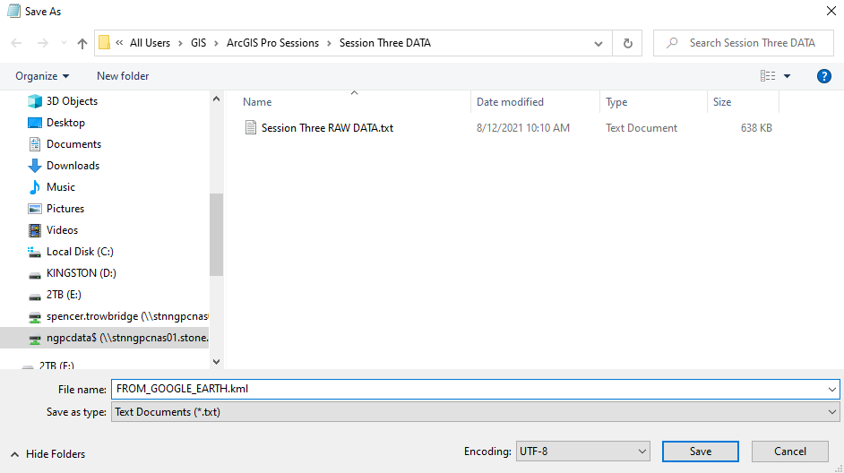

- Back in ArcGIS Pro in the Geoprocessing tab, type “KML to Layer”. Choose “KML to Layer (Conversion Tools)”.
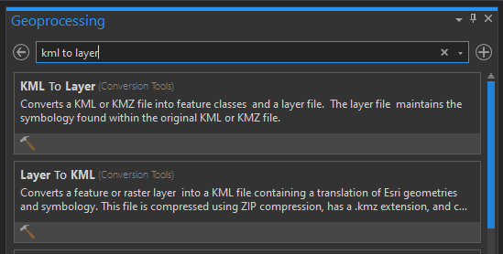

- Fill in the fields and name the new file, “FROM GOOGLE EARTH – KML FILE”. Press “Run” at the bottom of the tab.
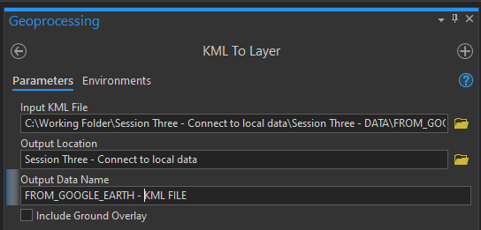
- The points are added to the map.
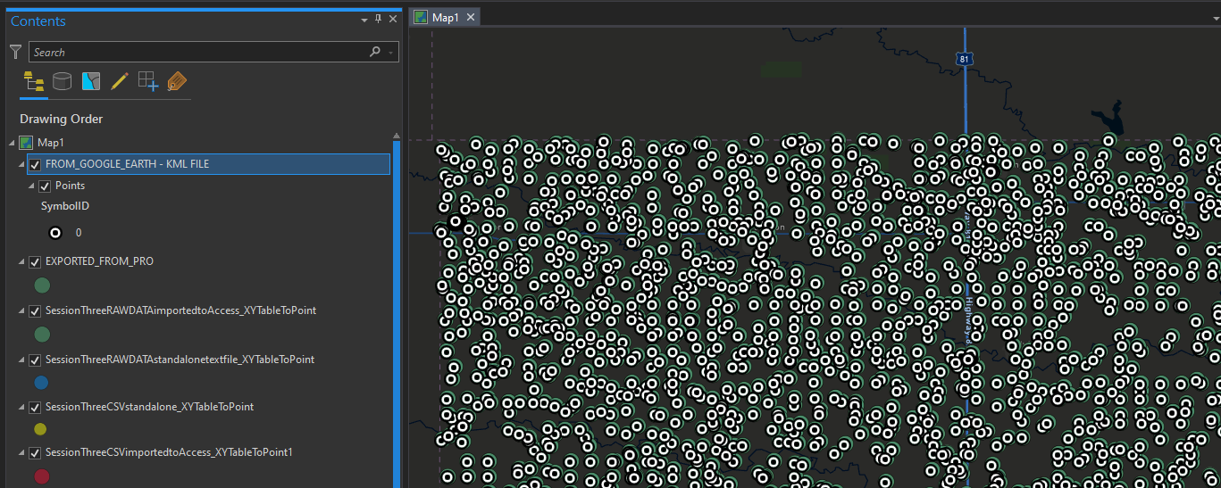

- Navigate to the “Share” tab at the top of the screen. Choose “Web Layer”.
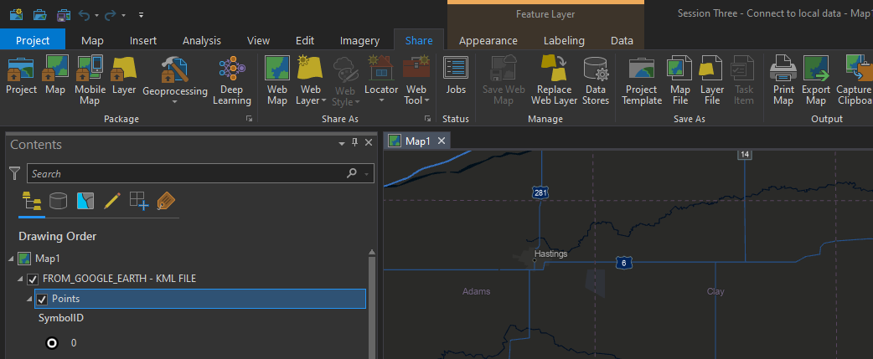

- Fill in the fields as follows followed by “Analyze”. You should receive warnings about not being able to publish two layers. This is expected. Go ahead and click “Publish”.
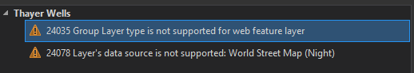

- The Publish should Fail due to some layers simply not being supported including the KML layer and the Tables. Remove all of the layers and tables Except the four XY Data Layers and republish the map.
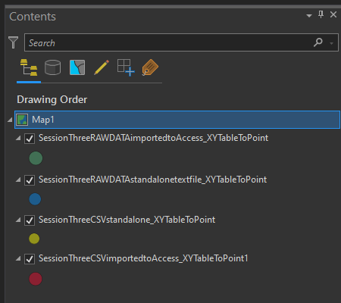

- The layer is successfullly published. NOTE: If you click “Manage the Layer” you will be taken to the properties page of the web map layers.
This is “ArcGIS Online”. These Layers can now be seen from anywhere on the planet. NOTE: Inspect the url at the bottom right of this page (scroll down to see it).
- Copy the url to the clipboard.
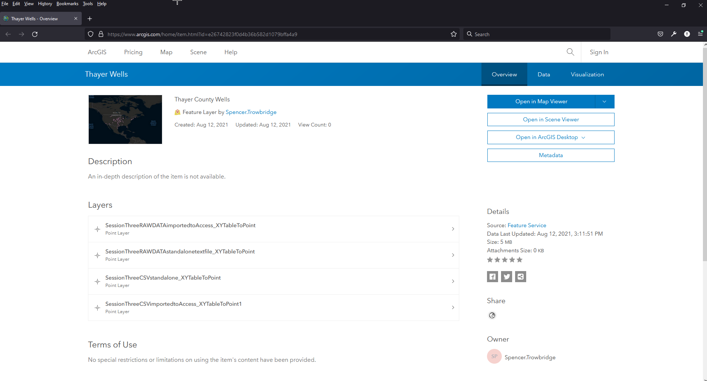
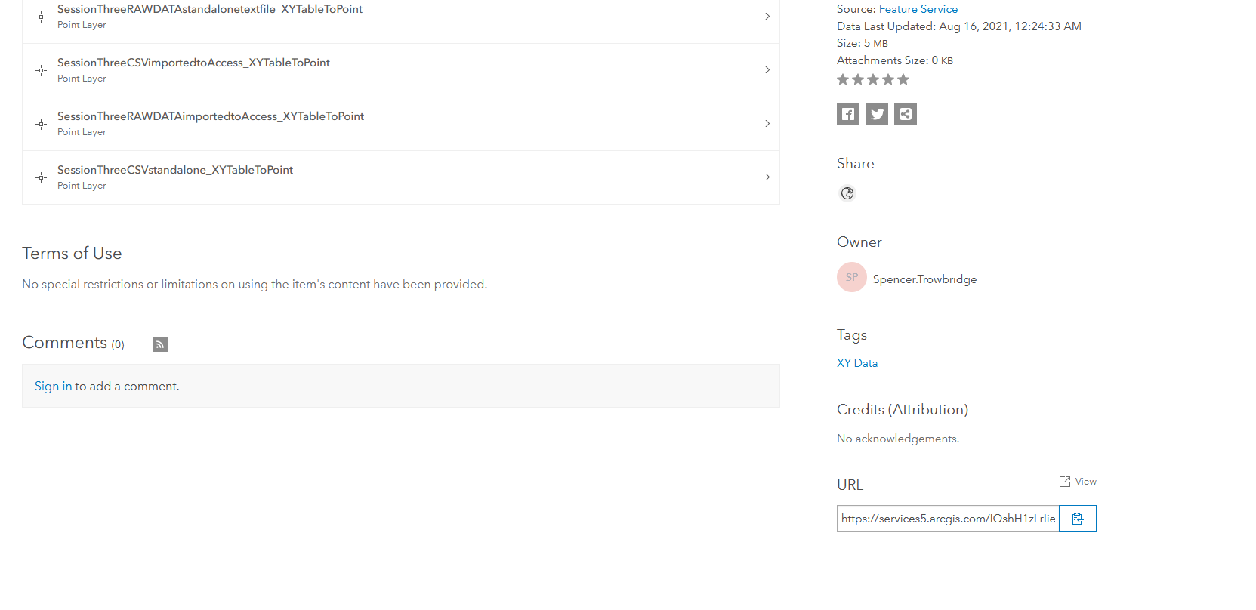
- Cllick “Open in Map Viewer” to see the layers displayed.
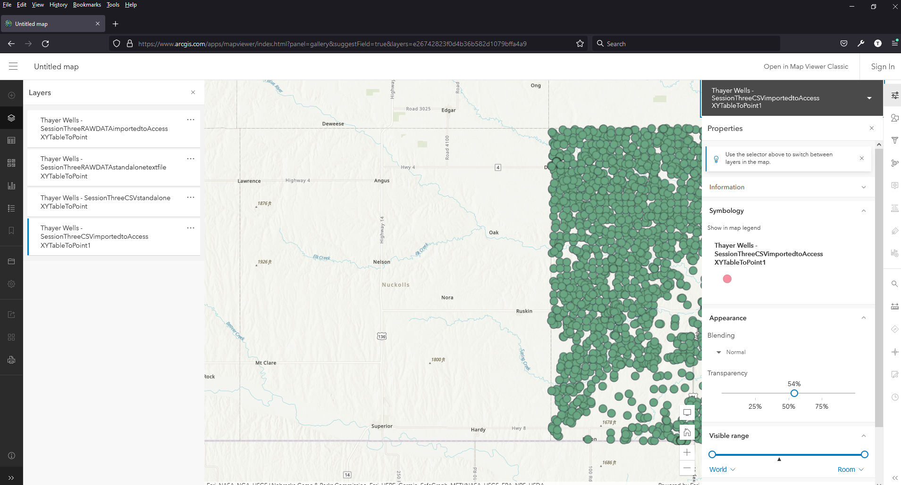
- Back in ArcGIS Pro, navigate to the “Catalog” pane at the right side.

- Right-click and choose, “New ArcGIS Server Connection”.
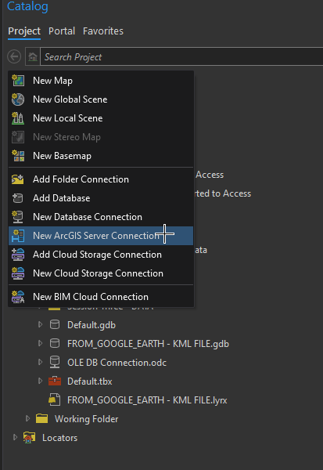
- Paste the contents of the clipboard (url) into the appropriate location for “Server url” and click OK.

- A new Service is added to the Catalog (FeatureServer on services5.arcgis.com.ags).
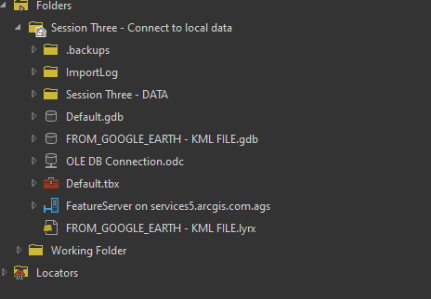
- Expanding the Feature Service for “Thayer Wells”, the name of our map shows the four layers that are now “Hosted” in our ArcGIS Online accounts. These can now be added “Back into Pro” showing that ArcGIS Pro can not only connect to local data, but also Web data, along with any feature class we choose to make or create using geoprocessing tools or selections based on Attributes or spatial queries such as “Contains”, “Near”, “Touches”, etc.
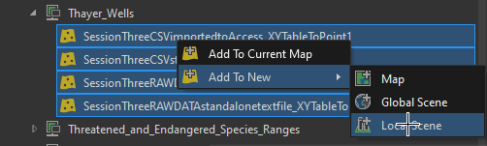

3D Scene Web Page showing wells of Thayer County, NE.
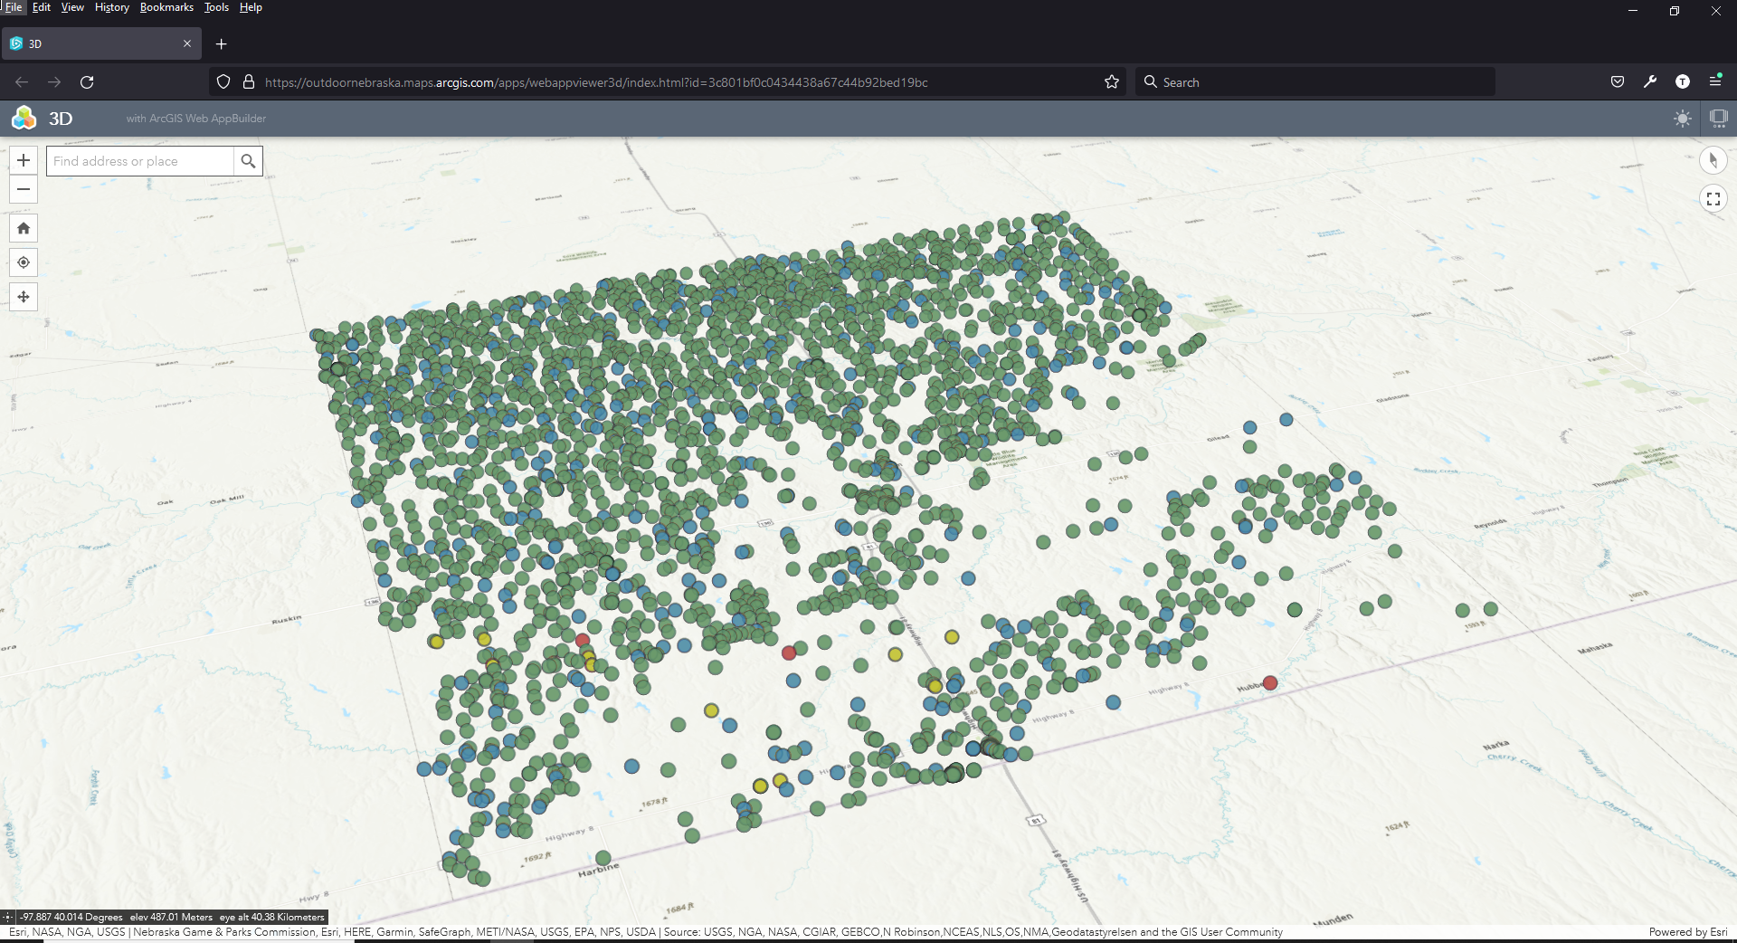

During this session you created a new ArcGIS Pro project and saved it locally. You also copied over raw data in two types of stand alone tables and imported them into that Pro project.
You also connected to a Microsoft Access database (.accdb) and imported tables contained within into ArcGIS Pro using the OLE DB connection type (Object Linking and Embedding Database).
A Shapefile was exported and then pulled into Google Earth. A technique for harvesting .kml files was also shown. One of those file types was then pulled back into Pro using the KML to Layer geoprocessing tool.
A Feature Service layer was also published to the ArcGIS Online account. This new layer was then pulled back into ArcGIS Pro using the ArcGIS Server connection. This now allows us to create web pages that can be seen from anywhere on the planet and make adjustments to those pages automatically.

